**Reinforcement Learning Coursework 2**

**WU Zhi 17040772** [**UCABWUA@UCL.AC.UK**](mailto:UCABWUA@UCL.AC.UK)

**Department of Computer Science**

**University College London**

# Part 1: Implement agents

## ****Agent 1 TD learning****

### Plot

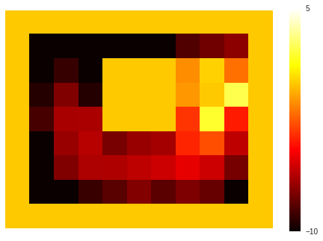

### Question

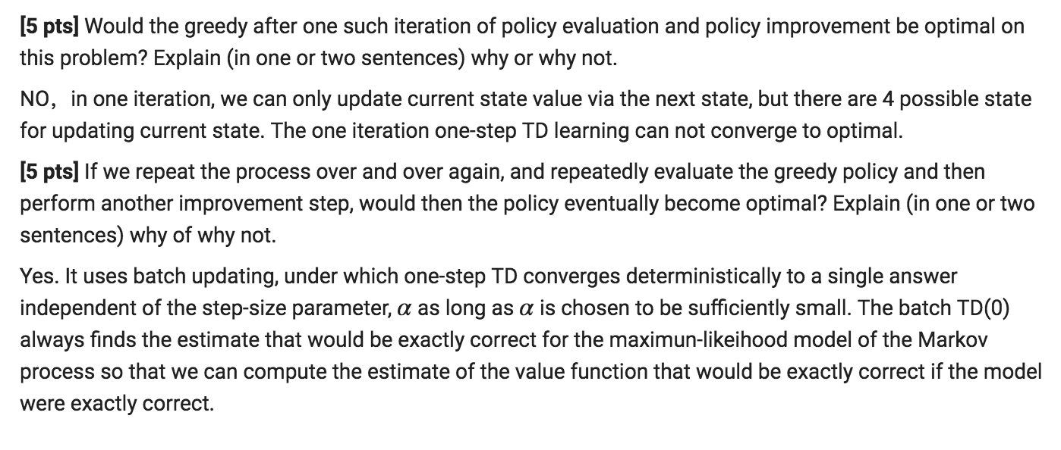

# Part 2: Analyse Results

### Plot

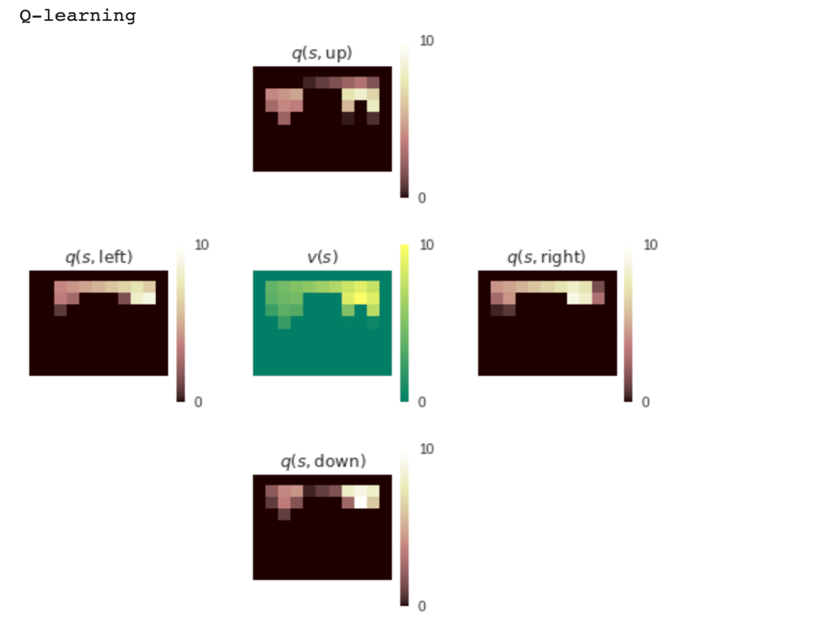

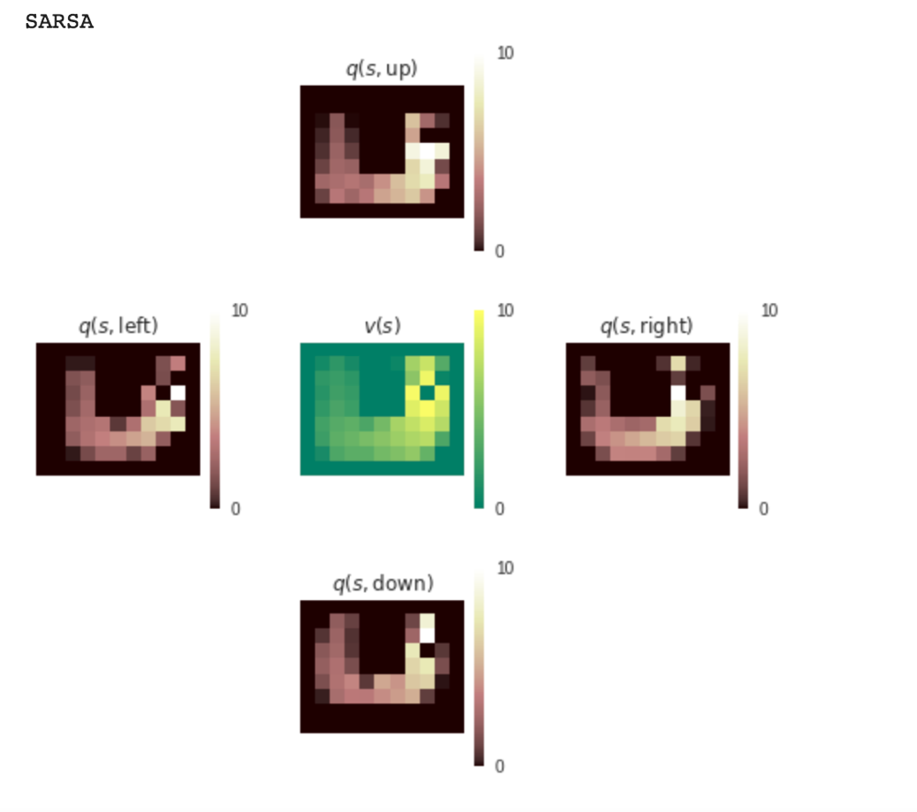

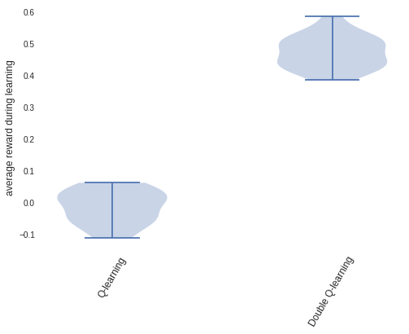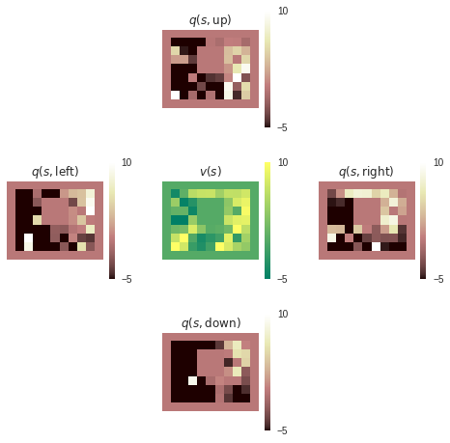

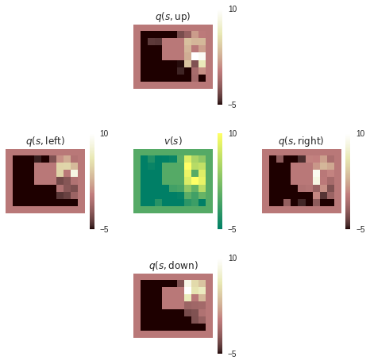

### Question

